The New Amway Center
Presentation and Strategic IT Project Management
Analysis

By: Joy Yashica Albert
Determined Marie Cascino
Determined Colette Martin
Changing Sally Spiwak

Professor Grady Meeks
ISM4011
4 December 2010

Table of Content Page
Introduction 3
SWOT Analysis 5
Strengths 6
Weakness 7
Opportunities 7
Threats 9
Advertisement 10
What the project/company does now 10
What the project/company plans to do in the future 10
Ideals project/company committed to 11
Project goals/deliverables 11
Project Manager Roles 12
Functional Head 12
Transformational Lead 13
Business Strategist 13
Smarter Project 14
Specific 14
Measureable 14
Achievable 14
Realistic 14
Time Specific 15
Ethical 15
Recorded 15
GUANXI 16
Kaizen 18
Risk Adversity 21
Work Cited 22
Introduction
The Amway Center is a new state of the art green facility. It opened its doors on October 1, 2010. The new center has replaced the old Amway Arena also formerly known as Orlando Arena, TD Waterhouse centre and The Arena in Orlando. The new center is an 875,000 square foot facility that sits on 8.75 acres. It is owned by the City of Orlando and located in the Parramore Neighborhood.
The history of the Arena dates back to 1983. The city of Orlando was looking to build an arena downtown to hold concerts and large scale event; they were a big thing at this time. After some financing issues, groundbreaking finally began in January 1987. Construction was complete in 1989 at a cost of $110 million, entirely publicly financed. The Amway Arena was also home to Orlando Magic Basketball Team. In 1989 the city allowed the Magic to sell the naming rights as part of a five year extension of the team lease of the building. In 1999 TD Waterhouse a division of Canadian finance company, Toronto Dominion purchased the rename and rights. December 7, 2006 it was renamed again. Magic owner De Vos co-founder of Amway Soap Products Company, used the name for the arena and sponsor. They agreed to pay $375,000 a year for 4 years.
The Orlando Magic wanted to renovate the building from as far back as 1994. The cost did not pay to renovate. In 2000 the Magic pushed to City of Orlando for a new arena. The Magic agreed to contribute to the building cost or they would go elsewhere. The team was losing $8 Million annually. The City of Orlando and the Parramore Neighbor started going downhill and tourist tax revenue dropped. Finally on September 26, 2006 the City of Orlando and Orange County finally agreed on the new arena with the Magic. Ground breaking for the new Amway center began July 26, 2007.
The Parramore neighborhood was home to many prominent African American citizens. The first commercial building was a blacksmith shop built in 1892. The first Orlando black chamber of commerce was formed and the first African American school was located here. The Mayor of Orlando wanted to revitalize this historic district. The areas needing help were: housing, public safety, business development children, education and quality of life. 73 % of Parramore 2000 lived in poverty and 84 % lived in single parent homes.
The new Amway center was the help the city needed. It brought in new jobs to the city and gave Parramore a re-birth of the city. The Amway Center is providing jobs and opportunities to residents and local businesses. A Blueprint employment office was opened to help residents with employment issues. The Center also plans to build a Central Florida Men’s Service center to help the homeless population, allow space for a farmers market, picnic area and playground. The New Amway Center has helped to turn this poverty stricken town around. With the help of the Magic, the city has remolded the Youth Center in the Parramore neighbor, which was moldy and infested with rats. The new center has been painted and had new carpets installed. It has also received new flat screen televisions, computers and central air. The project is also in the process of renovating the boys and girls club and providing the kids with school supplies.

Amway Arena – S.W.O.T
Table 1
S.W.O.T. Analysis
Strengths
Environmentally friendly design | Multipurpose
LEED Silver certified | Community focused
High tech

Weaknesses
Unreliably supported | Debt ridden
Compromised by location | Struggling to compete
Very easily congested

Opportunities
Outreach focused | Capital growth capable
Large capacity capable | Consumer attractive
Robust in products and services development

Threats
Sensitive to team availability | Susceptible to vendor competition
Vulnerable to economy fluctuations | Challenged by scalpers
Dependent on weather patterns

Strengths
From the very beginning (see table 1), the new Amway Center designers have focused on creating a sustainable site; providing water efficiency; optimizing energy and atmosphere protection; conserving materials and resources; monitoring indoor environmental quality and health; and selecting environmentally preferred operations and maintenance. These elements will combine to create one of the most environmentally friendly, high-performing professional arenas in the country. So in other words, the new arena is at its best in the world.
Another great aspect of the Center is its environmentally friendly design, so much so that it is on track to be the first professional arena constructed to be LEED-certified (Leadership in Energy & Environmental Design). The construction elements in place must meet strict protocol to even be considered for LEED certification, and the new Amway Center is doing its part to better the environment. Green technology makes the new Amway arena unique. The LEED-Certified Center will save 800,000 gallons of water a year thanks to its collection and efficiency procedures, while also saving about $750,000 in energy costs, a cut of 24 percent of compliance for new buildings.
Weaknesses
Orlando, Florida is a popular area for travelers. It only makes sense to build a lavish arena to house them right? Wrong! To begin with, Florida has no state tax because it is paid for by tourism. Furthermore, with the down swing in the economy, the tourism market has been devastated. Florida’s financial stability has significantly wavered. Also 15.9 % of the population and 13.3% of families live below the poverty line. In other words, some of these tax payers will never be able to afford a ticket to enter new Amway arena. This is why many residents of Orlando felt that, in a struggling economy, it was a misuse of tax dollars. Moreover, the fans may come but will they be able to leave? To explain: Orlando has very congested traffic and it is very possible that this will detour many fans, after having experienced it several times. Lastly, although the Orlando Magic will bring in the bulk of the profits earned by the arena, but what will happen if fans become less loyal? If the Magic have a few down years, ticket prices will plummet along with the attendance rate. Furthermore, if this arena doesn’t bring tourist and local dollars into Orlando’s economy on a consistent basis, it will be considered a failure.
Opportunities
However, inside the Amway Center, everything is new from the front row to the rafters. It showcases bigger seats, better sight lines, along with more amenities on every level of the building. Concourses will be spacious, offering unique concessions and activities for kids and adults alike. The Club Restaurant and the Ozone Bar will overlook the event floor, and children will enjoy spending time in the kid-oriented fun zone and retail store on the upper concourse. Technologically, Amway Center will be one of the most advanced ever built, highlighted by the main scoreboard – the largest of its kind in the NBA. Measuring approximately 42 feet high and weighing in at more than 40 tons, its four primary video displays will be able to show high definition imagery in 4.4 trillion shades of color. Altogether, it’s unlike any arena ever built. It’s a world-class experience unlike anything Central Florida has ever seen. In return with all the new amenities, the Amway Center will increase its profit from all the events that can and will take place.
The Amway Center is uniquely designed to stage every event with the highest possible production qualities such as: (see table 2)

Table 2

Unique stage design allows for special events
Home of the Orlando Magic | NCAA basketball tournaments |  | Ice shows
Home of the Orlando Predators | NBA All-Star game |  | Hockey championships
Elite concert series | Olympic Ice and Track Trials |  | Arena football
Extreme sports and motorsports exhibitions | Ultimate Fighting and Professional Wrestling |  | Indoor soccer
Professional Bull Riding and Rodeo |  | Other family events

Threats
As stated previously, the construction of this stadium is not a success. What revenues it generates will be the determining factor. Several threats could stand in the way of a financial breakthrough for Orlando, Florida. To begin with, the arena will make a great deal of money on concessions. Yet, local small businesses will try to take advantage of their location and attempt to sell their product to fans before they enter the stadium. If this gets out of hand, it could put a serious dent in their predicted gross income by the end of the year. Since the stadium is located in a poverty stricken area, there will be more scalpers harassing and soliciting guests, which can also create a safety problem. All in all, the biggest threat is failure. The Amway Center is projected to bring a certain amount of revenue to Florida. If this doesn’t take place, the citizens will be in an uproar and at the absolute worst the franchise could pick up and leave. The city of Orlando would then be left with a large bill, a lavish stadium and no team to play in that stadium. (See table 3)
Table 3 The new Amway Center Aerial View
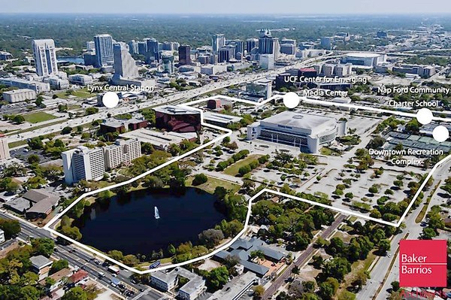

Advertisements
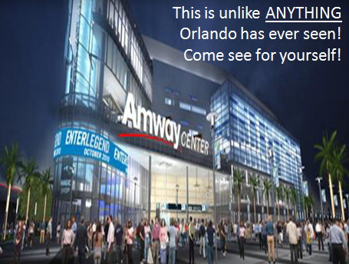

Project Management: Transformational Lead
Empowerment
Table 4
Project Management Life Cycle

The Project Management Life Cycle has four phases: Initiation, Planning, Execution and Closure (see table 4)

Table 5 Tools
Table 5
Amway Center
Define the Amway Center project (why is it needed? what role will it serve?) | User 1
What local services already provide a similar role? | User 2
Consider the following systems and how they might relate to the Amway Center and used during the building process:  Supply Chain Management systems Customer Relationship Management Systems | User 3
page 59
Discuss what licenses the Amway Center could use to enhance their profit and usability? | User 4
Table 6 Excel: Timeline/Deliverables
Key Performance Indicators | Date | Key Performance Indicators | Date | Key Performance Indicators | Date
City of Orlando and Orange County finally agreed on the new Amway Center | 9/26/06 | Building Approved by Orange County Commission | 7/26/08 | Amway Center was Named | 8/5/09
Design Unveiled | 12/11/07 | Ground Breaking | 7/29/08 | Amway Center Opened | 10/1/10
This tool, created in Excel, and displayed on a shared website to can be used by the team to:
*Communicate time needed for individual contributions
*Serve as a launch for all team members + initiate dialog
* Deliver and manage projects
*Iterative responses in a timely manner
*List timeline/key performance indicators (see table 6)

Using tools as Excel and displayed on a shared website will:
*Reduce time spent analyzing pertinent information
*Serve as a communication point for all team members
*Meet basic requirements (see table 5)
Project Management: Transformational Lead
Empowerment (process)
(see table 7)

Transformational process for the team to:
*Communicate | *Record |  | *Analyze |  | *Record
*Customize  Table 7 Transformational Process |  | *Record |  | *Publish
Daktronics, Inc. will WOW the world with its integrated super system both inside and outside the Amway Center to bring the audience a full digital experience. Will it be prudent to put ALL of the eggs in the Daktronics’ basket, or should the Amway Center have its own key support? Short and long range bottom line goals point to the success of this super system as it grows and improves into the future (see Table 7a). As the Amway Center begins to answer the community’s questions for appropriate venues, the super system will modify and improve to meet those needs. Staying on top of the entire system, the Amway Center can hold close the control and supervision that is needed to best benefit the Orlando and surrounding communities. Turnkey systems have their benefits, but as this center becomes integrated into the central Florida community, procedures will need to be in place for optimum success for a robust system that will continue to support the specific IT requirements to maintain and upgrade what is taking place on the “ground level”. As the venues’ systems become more complicated and demanding, the Amway Center’s IT department will step up to the plate to support and implement a successful system to pull off the shows for excited audiences.
Project Management: Business Strategist
Amway Center Short & Long Term Bottom Line Goals
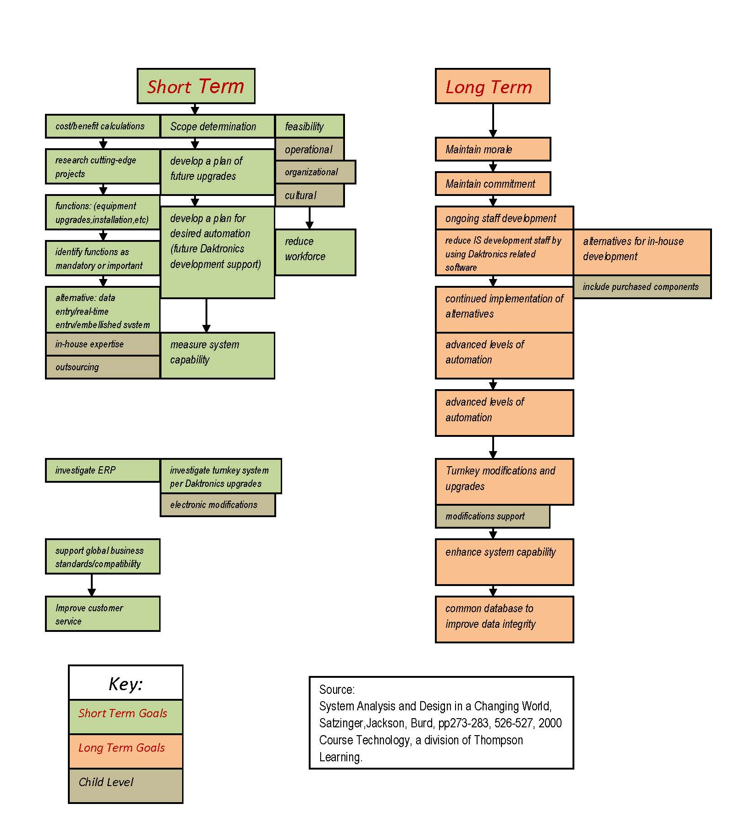
Table 7a Amway Center Short and Long Term Goals supporting the Daktronics, Inc Super System

SMARTER Project
S = Specific
The Specified Steps that take Place in Completing a Project
On July 26, 2007 the Orange County Commission approved a state of the art events center, performing arts center and renovation to the citrus bowl stadium. The ground breaking was held on July 29 2008. August 5 2009 the Amway Center was named and October 1, 2010 the Amway center opened. It is owned and operated by the City of Orlando. It will hold national events, concerts and shows.
The City of Orlando began a revitalizing program of the Parramore neighborhood, which is home to the arena. The city worked closely with local minority and women owned businesses to build this environmentally friendly building. It is designed to reflect the community. The new center has a blend of glass and metal with an ever changing graphic monumental wall. The Amway Center is 875,000 square feet. It is also constructed as an environmentally “green” building.
The Magic contributed $50 million toward the construction of the center that sites in 8.75 acres. The new Amway Center has 8 levels, holds 20,000 seats and has 11,000 parking spaces in the area. The new center also has retail stores, restaurants and bars. There is also an iconic 180 foot tall tower with sky bar and sky terrace at the top.
The City will also be conducting a community venue project. The city will help residents get jobs and clean up the Parramore neighborhood. The Parramore Heritage Park has space for outdoor activities. They built a kids monument and will construct a playground for the children later this year. They will also be repairing and adding new sidewalks with ramps for safety. The city also put up new street lights for safety and planted some trees. They also put up new decorative fencing on main roads that lead to the interstate.
The old arena will be demolished and the land turned into a Creative Village. It will house digital media companies. There will be office space, residential space and room for education, hotels, retail and entertainment. The goal is to turn the site into a place where people live work and play.
Measureable
Outcome of a notable change or benefits produced from change. (See table 8)
Environmentally Friendly  Table 8  Measureable  Benefits | Money to community
Community gathering place | 1400 Central Floridians found jobs
Employment in the community | 430 Parramore Residents now have jobs
New retail stores, Restaurants &bars | Refurbish Parramore Youth Center
Renovate Boys and Girls Club
Table 9
Successful Goals
A = Achievable
Set goals successfully carried out (see table 9)

December 11, 2007 Design was unveiled
July 26, 2007 Building approved by Orange County Commission | Sept 30, 2010 Amway Arena closed
July 29, 2008 Ground Breaking | October 1, 2010 Amway Center opens
August 5, 2009 Amway Center was named | Away arena will be demolished by end of 2011
Sun Rail Commuter Railroad will stop at Arena 2012

Realistic
Skills, Knowledge, and training needed for project
The skills that were used to complete the project were excellent communication, computer skills, team work, goal sitting, and outstanding time management. The knowledge that was need to complete the project are as follows: understanding the meaning of SWOT and how to define the concepts, advertisement, understanding the managers roles, business terminology and the ability to work with cited information used to complete the project. The training need in order to complete the project was some form of business courses such as business writing, strategic management, and business leadership.

Time Specific (Start and End Date) see table 12
September 26, 2006 the City of Orlando and Orange County finally agreed on the new arena with the Magic.
July 26, 2007 Building approved by Orange County Commission
July 29, 2008 Ground Breaking
August 5, 2009 Amway Center was named
Sept 30, 2010 Amway Arena closed
October 1, 2010 Amway Center opens
Table 12 Time Specific
E = Ethical
Optimal manner to implement project/maintain Quality of Service, no “shortcuts/patchwork/quick fixes” (see table 10)

Table 10 Project focus: Daktronics Inc. Ethics/Reputation
has experience and reputation in the industry
has ability to deliver truly integrated scoring and video display systems in a turnkey fashion
provides service for the life of the equipment
creates a system that will ‘wow’ fans
will provide programming flexibility
ensures robust software
is a company that excels in the control of large display systems
has strong leadership positions in, and is the world’s largest supplier of, large screen video displays, electronic scoreboards, computer-programmable displays, digital billboards, and control systems

Recorded
Detailed Statement of Work/Plan of Action for Project Success (see table 11)
Table 11 Project focus: Daktronics Inc. Recorded
provides an integrated scoring, video and advertising display system
Installs of the first displays of the multi-million dollar system will begin in early 2010
creates a high definition super system
builds one of the world’s largest suspended scoreboards
installs two LED ribbon boards mounted on the interior fascia of the seating decks
has the ability to present exciting motion graphics and real time content
networks portal displays on various levels of the arena
builds twenty-seven smaller full-color digital displays
mounts unique technology on the exterior of the building in an open-air concourse area
installs a curved LED display on the building’s corner “tower”
sets up a show control that is compatible with all components
displays 41 digital clocks
GUANXI
The Deal – Who Pays for What and How?
The Amway Center is part of the Orlando Downtown Master Plan 3: a plan that also involves improvements to the Citrus Bowl and a new performing arts center. On September 29, 2006, after years of negotiations, Orlando Mayor Buddy Dyer, Orange County Mayor Richard Crotty, and the Orlando Magic announced an agreement on a new arena in downtown Orlando. The arena itself cost around $380 million, with an additional $100 million for land and infrastructure, for a total cost of $480 million. It was part of a $1.05-billion plan to redo the Orlando Centroplex with a new arena, a new $375-million performing arts center, and a $175-million expansion of the Citrus Bowl, which due to current economic conditions is delay until at least 2020). The Orlando Downtown Master Plan 3 has been described as the "Triple Crown for Downtown".
The agreement between the Orlando Magic and the City of Orlando was made public in December 2006. In that agreement, the Orlando Magic was to contribute at least $50 million in cash up-front, pick up any cost overruns, and pay rent of $1 million per year for 30 years. The City of Orlando was to pay for the land and infrastructure and the remaining money coming from bonds which would be paid off by part of the Orange County Tourist Development Tax. The Orlando Magic guaranteed $100 million of these bonds. According to the Orlando Sentinel, “The deal keeps ownership of a new events center in the city's hands and locks in the team's promise to cover any cost overruns. But team officials will be allowed to pick the architect and construction team, as long as the Magic bid out the projects in the same public way that a local government would be required to do. The team also negotiated the city into giving up its concession revenues from basketball games, which it currently shares. In return, the Magic will fork over a greater share of advertising, naming-rights and luxury-suite sales to the city in the form of guaranteed annual payments.”
Although all reports currently show the Amway Center came in on budget, there is a major financial hurdle that arose in April of this year. The Fitch Rating Agency downgraded the bonds used to finance the arena to "junk" status. They also warned the arena's debt holders that in as soon as 30 months the new Amway Center could be faced with a default unless finances are corrected. The City of Orlando was quick to assure that in no way would Fitch's downgrade delay construction and that all necessary funds were there to complete the center. However, because of the Fitch downgrade, the interest rate on the debt would increase the "payoff" cost of the Amway Center over time. This downgrade to "junk" of the Amway Center's debt--although reversible--signals that unless local government either expands tax revenue or drastically reduces both Amway Center and non-center expenses, creditors could in just a short few years seek bankruptcy relief in the form of repossession or auctioning off the new center.

Kaizen
How It Affects the Citizens and the Area
So how does the construction and operation of a multi-million dollar complex impact the citizens of Orlando and Orange County?
According to the Amway Center press release, “the massive construction project served as a boon to the local construction business in a time when jobs were scarce because of the sharp downturn of the nation’s economy. The Orlando Magic and City of Orlando worked closely with local minority and women-owned businesses — some of which were based out of the nearby Parramore community — awarding them with more than 30 percent of the contracts totaling $90-plus million, exceeding the 24 percent benchmark established by the City of Orlando. Of the 170-plus minority and women-owned firms who worked to construct the facility, 61 were African-American-owned firms, 51 women-owned firms, 36 Hispanic-owned firms, 20 Asian-American-owned firms and two Native-American-owned firms.”
Parking in Downtown Orlando is expensive. The demand for parking has intensified with the recent opening of the Amway Center. While the arena has 18,500 seats, the new garage built next to it has 1,285 parking spaces and 600 of those are reserved for the Magic and premium-ticket holders. There are a total of 16 parking garages in the Downtown area totaling 7,475 parking spaces. Of those 7,475 parking spaces, 1,108 charge $20 per space and the other 6,637 charge $10.
If the Amway Center sells out the arena for an event and at least 2 persons ride in vehicle, 1,775 parking spaces are still needed. Some innovative residents in the Amway Center neighborhoods are providing for this need by offering parking in their yards and driveways for a fee.
The Amway Center is revitalizing downtown Orlando. The restaurants in the area are experiencing an influx of patrons. The new Mojo Cajun Bar & Grill already has become a pre-game hot spot, bringing in several times its normal revenue on nights that the Magic play, co-owner John SanFelippo said. Hamburger Mary's owner John Paonessa said business was up 40 percent last month. Baby Grands, a piano bar on Church Street, has also noted having a stronger clientele since the opening of the Amway Center. At Kres Chophouse, managing partner Billy Ray Deans said the Amway Center has helped his restaurant "100 percent." On nights the Magic play, Paradise Island can bring in four or five times as much money compared with other nights, co-owner Marjorie Brown said.
Hotels in the area are also experiencing a higher occupancy since the Amway Center opened. Mark Moravec, general manager of the Sonesta Hotel in downtown Orlando, said he's not sure whether the arena or an improved economy is the main reason his occupancy rate is up. But he's thrilled his hotel is 92 percent full compared with a little more than 80 percent this time last year. "Either way, I don't really care — it still makes me feel good," he said. "It's nice that we're seeing year-over-year increases and that's the most encouraging thing."
The Amway Center is also helping the community by assisting in charitable work. Recently, Ringling Bros. and Barnum & Bailey collected 2,950 pounds (nearly 1.5 tons) of food to help stock Second Harvest Food Bank of Central Florida (SHFBCF)’s pantry shelves during a drive-through food drive held at the Amway Center. The amount of food equates to approximately 2,000 meals to feed the needy in Central Florida. Those who donated food got a voucher and they can return to the Amway Center box office now through Jan. 13 to redeem vouchers for tickets to the upcoming Ringling Bros. and Barnum & Bailey show.
Many area high schools held their graduations in the old arena so there would be room for student to invite guests, but most who attended these graduations felt too far away from the actual graduation or too close to those sitting next to them. The graduations will now take place in the new Amway Center and with new 42-foot by 41-foot jumbotron, no one will feel too far away anymore.
So the new Amway Center is actually a win-win for the residents and businesses of the City of Orlando and Orange County. The only downside, according the residents, is the traffic has increased in the Downtown area and even that is not a bad thing as it is bringing more business to the area.

Risk Adversity
There are two main risks for the new Amway Center. One that has been previously mentioned are the bonds used to finance the arena have been downgraded to “junk” status. With this downgrade, the possibility of losing the center to bankruptcy is high and very possible in just a few years.
The other main risk is that in order to sustain the economic boon to the area and to be able to maintain the new Amway Center, they have to be able to book high profile events and performances that will draw large numbers of consumers. The Orlando Magic only play in the arena during basketball season – 82 regular season games in a period of approximately 9 months. Only half of those are played at home, so the arena will only host 41 games. With that stated, that is 324 days in a year that other events and performances must be scheduled. As of now, only 10 events in the month of December, 16 events in January and only 9 events in February have been scheduled. (see table 11)
Table 11 Schedule of Events

Unfortunately, only time will tell if they are able to attract the events and performances that will be needed to run their facility at a profit and continue to bring business to the area.
Works Cited:
Amway Center, "Amway Center Home Page." 4 Dec 2010. Amway Center.
<http://www.amwaycenter.com/>

Amway Center, "Concerts and Events." 4 Dec 2010. Amway Center.
<http://amwaycenter.com/concerts-and-events>

Amway Center, "About the City of Orlando." 4 Dec 2010. Amway Center.
<http://amwaycenter.com/about-city-orlando>

Amway Center, "Promoter Guide." 4 Dec 2010. Amway Center.
<http://amwaycenter.com/promoter-guide>

Amway Center, "Press Room" 4 Dec 2010. Amway Center.
<http://amwaycenter.com/press-room>

Amway Center, "Venue" 4 Dec 2010. Amway Center.
<http://www.amwaycenter.com/venue>

Barrett, Alex, "Amway Center a Magical New Home for the NBA and Orlando." 2010
CBSSports.com
<http://bleacherreport.com/articles/479529-amway-center-a-magical-new-home-
for-the-nba-and-orlando>

City of Orlando. "History of Pathways for Parramore." 2010. City of Orlando. 1 Dec 2010
http://www.cityoforlando.net/elected/parramore/history.htm

Dyer, Buddy. "State of Downtown Address." 1 Oct 2010. City of Orlando.
<http://www.cfnews13.com/static/articles/images/documents/State-of-Downtown. 2010.pdf>

FloridaBrazil.com, "Orlando Florida City Guide." 2010. FloridaBrazil.com.
<http://www.floridabrasil.com/orlando-florida-vacation-travel-guide.html>

Munsey & Suppes."Amway Arena."2010. Ballparks.com.
<http://basketball.ballparks.com/NBA/OrlandoMagic/index.htm>

Satzinger, John W., Jackson, Robert B., Burd Stephen D.,
System Analysis and Design in a Changing World.Cambridge: 2000 Course
Technology Thompson Learning, 2000.

Steinkamp, Mark,"Orlando’s New Amway Center to Feature Daktronics Integrated
Super System" 11 Nov 2009. Daktronics.com
http://www.daktronics.com/Company/NewsReleases/Pages/OrlandoMagic.aspx

Amway Center, “Press Release” 4 Oct 2010. Amway Center
<http://amwaycenter.com/press-room/press-releases
Orlando Sentinel “Orlando Magic Reach Fair deal on arena details” 23, Dec 2006. Orlando Sentinel
<http://articles.orlandosentinel.com/2006-12-23/news/ARENA23_1_orlando-magic-deal-city-commissioners

Orlando Sentinel “Orlando risk default on Magic arena bonds, Analyst warn” 3, Apr 2010 Orlando Sentinel
<http://articles.orlandosentinel.com/2010-04-03/news/os-magic-arena-junk-bonds-20100403_1_arena-bonds-default-fitch-ratings

Orlando Sentinel “Orlando’s newest landmark” 14, Nov 2010. Orlando Sentinel
<http://www.orlandosentinel.com/sports/highschool/varsitylife/os-amway-varsity-life-111410-20101114,0,4884856.story

Orlando Sentinel “Cha-Ching! Florida Classic is a Multimillion-Dollar Boost to region.”19, Nov 2010 Orlando Sentinel
<http://www.orlandosentinel.com/news/local/os-florida-classic-advance-20101119,0,5121074.story
Orlando Sentinel “Circus food drive collects nearly 1.5 tons of food” 18, Nov 2010 Orlando Sentinel
<http://blogs.orlandosentinel.com/entertainment_stage_theat/?p=10408

